Results & Discussion

Underline are possible sections to include

Italics are possible figures and tables to include

Database overview

We located fifteen articles that fit our criteria, representing 123 response ratios for weed biomass and 110 response ratios for weed density.

*Figures/Tables: Table of studies, map (F1)*

|  |  |  |  |  |
| --- | --- | --- | --- | --- |
| State | Cover crop species | Season of weeds measurement | Crop following cover | Reference |
| IL | cereal rye, vetch | summer | soybean | Davis (2010) |
| WI | cereal rye | summer | soybean | Bernstein et al. (2011) |
| MN | cereal rye | summer | soybean | De Bruin et al., 2005 |
| MI | mogul medic, red clover, berseem clover, santiago medic | spring | corn | Fisk et al., 2001 |
| MN | cereal rye | spring | soybean | Forcella 2013 |
| IA | winter wheat/winter pea, cereal rye/vetch | summer | soybean | Delate et al. 2012 |
| OH | winter wheat, hairy vetch | summer | soybean, corn | Gallagher et al., 2003 |
| MN | radish | summer | corn | Gieske et al., 2016 |
| OH | hairy vetch | summer | corn | Hoffman et al. 1993 |
| IN | winter wheat, annual rye grass | fall | corn, soybean | Mock et al., 2012 |
| NE | cereal rye | spring | corn | Werle et al., 2017 |
| IL | radish, canola, rye | summer | soybean | Crawford et al., 2018 |
| MO | austrian winter pea, hairy vetch, crimson clover, oilseed radish, winter oat, italian ryegrass, rye + vetch, rye, winter wheat | spring | soybean | Cornelius and Bradley, |
| KS | winter wheat | summer | corn | Currie and Klocke, 2005 |
| NE | barley, cereal rye, triticale, wheat, vetch | summer | soybean | Williams et al., 1998 |

Differences in weed biomass vs. weed density

Experiments show that cover crops are generally more effective at reducing weed biomass (size of weeds reduced in 95/123 response ratios or 77%) compared to weed density (amount of weeds reduced in 62/110 response ratios or 56%). This suggests that cover crops may be more beneficial from the standpoint of controlling the size of weeds rather the amount of weeds. This finding may have important implications for the efficacy of other weed management approaches, such as herbicide programs or mechanical approaches; if cover crops can reduce the size of weeds, this is rationale for their inclusion in an integrated weed management approach.

Could talk about timing of measurement here. It does appear that the most neg RRs are from the measurements taken in spring (spring measurements have two values-need to fix this in the database). Preliminary stats shows a significant difference between the groups for both weed density and weed biomass. This is something to explore in more detail – we are really not seeing an effect on weed density for any of the variables. But timing could be the key.

It is interesting to note that there were a number of experiments where cover crops led to an increase in weed density, counter to what we anticipated we might find. In general there are several possible explanations for why this occurred. It is possible that interactions with the cover crop biomass and herbicides applied for weed control and/or cover crop termination reduced product efficacy. It is also possible that for a variety of reasons the cover crop treatments created a more favorable environment for weeds (i.e. soil moisture retention). Most all of the experiments included in this analysis note in their rationale that weed control with a cover crop was an explicit goal of their experiments, so we can assume that experiments were designed to see reductions in weeds by including a cover crop.

*Overall distribution separated by biomass and density (F2) – could code this by season of measurement*

|  |  |
| --- | --- |
|  |  |

Termination method

Updated database does not show significant differences between termination methods groups for either weed biomass or weed density. Figures suggest that herbicides were most effective termination method for reducing weed biomass, which could be different from the effect herbicides have on weed density – per seedling biomass would be less. Previously we had been describing this as: experiments that used herbicides or a combination of herbicides and mowing to terminate, or cover crops that were winter-killed were found to be more effective at weed control than cover crops terminated solely by crimping or mowing. In particular DeBruin found two glyphosate applications to be the most effective termination method. Evidence from studies in the southeast suggests that herbicides applies later in the season or with residual action were most effective at weed control in tandem with cover crops (Norsworthy et al. 2016; Wiggins et al. 2014; Montgomery et al. 2018).

*Figure of distributions broken out by termination method (F3)*

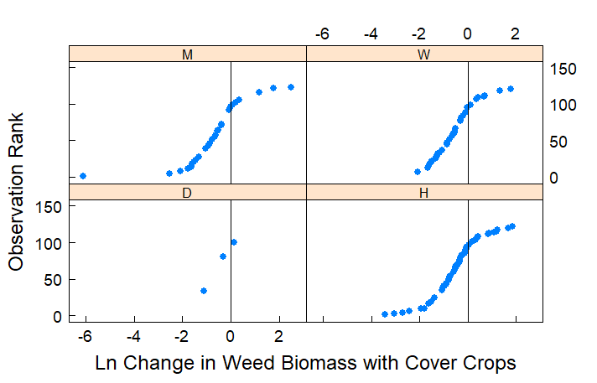

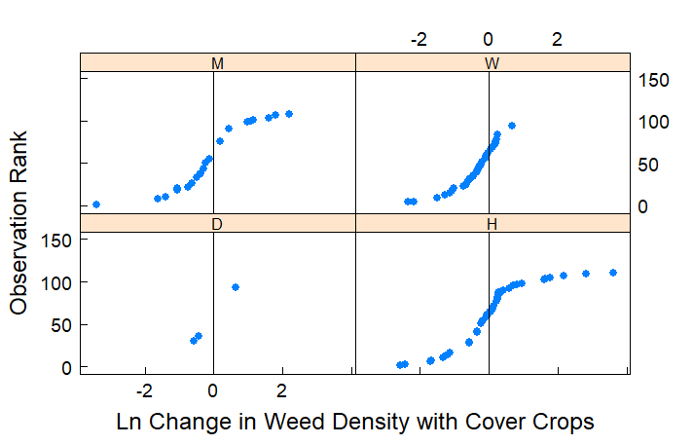

Biomass production

When a cover crop preceded corn, cover crop biomass of approximately 4000 kg ha-1 tended to consistently reduce weed biomass and weed density. When a cover crop preceded soybean, results in our analysis were variable; some experiments showed significant weed control with smaller amounts of cover crop biomass (<1000 kg ha-1), while others had ineffective weed control with smaller or larger amounts of cover crop biomass before soybean.

*Regression type figure of response ratios by biomass, could be sorted by crop following or cover crop species or both (F4)- note that if we include a regression line it not a good idea to include groups beyond the two panels*

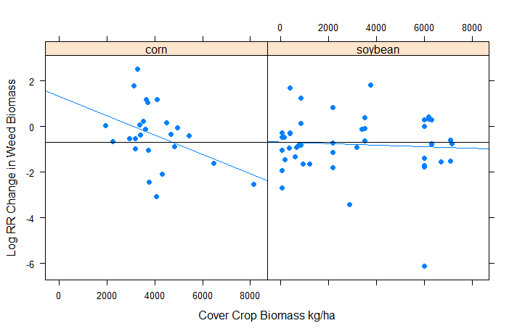

Cover crop species

Experiments included in our analysis utilized grass, legume and mixed cover crop species. We did not find differences in the efficacy of weed density control with different cover crop species, but did see a significant difference in cover crop species for weed biomass control (when analyzing type as a fixed effect in our mixed effects model, to be clear).

*Figure of distributions broken out by cover crop species (F5 – if not included in F4). This mostly looks like the same trend as F2 will show –weed biomass is better controlled with cover crops than weed density. The stats results suggest that grass cover crop species are more effective at reducing weed biomass.*

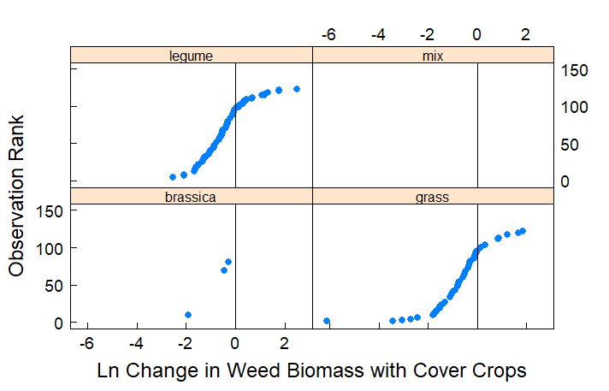

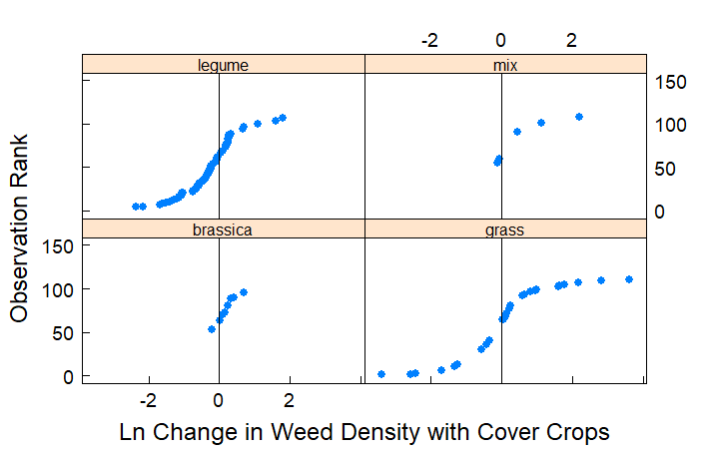

Crop following the cover crop – from here down still needs to be updated

Maybe no new figure here if included in F4

Crop yields

When experiments included yields we found that cover crops represented “win-win” scenarios 18% of the time, where weeds were reduced and yields were increased. “Lose-lose” situations (weeds increased and yield decreased) represented 46% of possible response ratios. Our analysis confirms other work that corn following a cover crop in the North Central region can decrease yields (Miguez and Bollero 2005; Marcillo and Miguez 2017).

*Figure: Win-Win plot (F5 or F6)*

Weather/GDDs/Precip

Need to add more to the database on this front

Organic experiments (maybe)

Four experiments. Mostly ineffective. None fell into the win-win category.

*Figure: Possible win win plot just for organic experiments, or distribution of these studies together*

Other things we may want to evaluate papers for:

Was weed control an explicit goal of the experiment? Note: This is addressed above

When were weeds measured? – Note that we know have a variable for summer vs annual weeds

Community of weeds vs individual weed species?

Is the method of planting stimulating weeds?

Need to add weather in some way

Other ideas to include in the discussion:

Long term weed seed bank changes with a cover crop

Management of herbicide resistant weeds

CC biomass relationship to yield